ACG Patient Need Groups: What are they and how are they used in healthcare? What are the John Hopkins Patient Need Groups (PNGs)?

Patient Need Groups categorise patients into different groups based on the complexity and intensity of their healthcare needs rather than just their medical conditions. Instead of focusing solely on a diagnosis (like diabetes or heart failure) it takes into account a broader range of health characteristics a patient may have. To begin with, we will roll out PNG segmentation to those patients with highest needs, and you may therefore not find a PNG score in your NHS app unless you would be categorised as PNG 10 or 11.
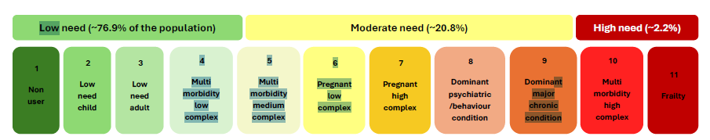
These groups consider factors like the number of chronic conditions, the severity of illness, and the level of support a patient might need. The patients in a particular group have similar patterns of need.
For example:

Red PNG 10 and 11 = complex care needs, patients with multiple chronic conditions requiring regular monitoring and a coordinated care approach.
Amber PNG 5 – 9 = stable chronic conditions, patients with chronic conditions that are well-managed and require occasional support to maintain their stability.
Green PNG 1 - 4 = healthy, patients without significant health issues who require less intervention and could benefit from preventative care.

As patient needs change over time, their categories changes with them. PNG numbers therefore offer an indication of a patient’s background health, at a point in time.

What are the benefits of having this information available on patient records?

- Personalised care. Healthcare providers can use PNGs to tailor their care plans. This means that patients receive the specific type of care they need, whether it’s more frequent monitoring, specialised treatment, or preventative care.
- Improved coordination. PNGs help healthcare teams coordinate more effectively. If a patient has complex needs, the care team can work together to ensure all aspects of their health care addressed, from medication management to lifestyle support.

3. Better recourse allocation. Hospitals and GP surgeries can allocate resources more effectively based on the needs of different patient groups. This ensures that patients with the most urgent needs receive timely care, while those with less critical conditions are managed appropriately.
4. Proactive health management. For patients in lower-needs groups, PNGs encourage preventative care and early intervention. This can help them maintain their health status and avoid complications in the future.
5. Enhanced communication. PNGs facilitate better communication between patients and healthcare providers. By understanding which group a patient falls into, together they can have clearer discussions about what to expect from the care they receive and what actions they can take to manage their health.
-----------------------------------------------------------------------------------------------------------------------------------------------------------------

